Report on National Union of Teachers (NUT) Visit to Nicaragua, 13-18 June 2016

From 13-18 June, Christine Blower, former NUT General Secretary and Samidha Garg, NUT International Officer, visited Nicaragua at the invitation of Nicaraguan Teachers’ Union ANDEN The purpose of the visit was threefold: to reestablish contact between the NUT and ANDEN, to visit schools both urban and rural to focus in particular on the teaching of English and to visit a computer project which the NUT has been supporting over the past year.

The delegation achieved its objectives in terms of re-establishing a good relationship with ANDEN. The delegation was very warmly received. A proposal for teacher exchange to focus on the teaching of English is likely to be forthcoming. It will be jointly written by the union and MINED (ministry of education) and the NUT will be considering ways in which it can support the proposal.

A copy of the delegation’s programme can be found here

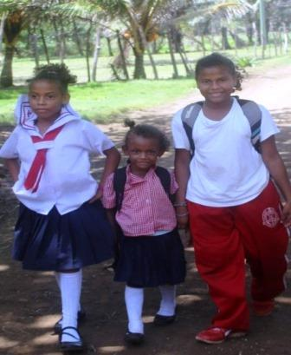

Photo: Steve Lewis – children on their way to school

CONTACT WITH ANDEN

Members of the National Executive Committee of ANDEN met with the delegation to give an overview of their work and current education policy in Nicaragua. The FSLN Government is very serious about poverty reduction, school attendance and improving the quality of education in Nicaragua. The this end they have introduced universal free education from pre-school through university, a universal free school meals programme, parenting classes in pre-school and monthly Continuous Professional Development for all teachers. ANDEN enjoys a good relationship with the Government, is affiliated to the FSLN (Sandinista National Liberation Front) and is therefore sympathetic to Government policy.

A number of prominent ANDEN members, including General Secretary Professor Jose Antonio Zepeda, are also members of parliament and involved in the country's Education Commission.

During the visit the delegation met the Education Minister's key adviser on education policy and the parliamentary Education Commission.

SCHOOL VISITS

The delegation visited schools in Managua and Leon as well as a rural school en route to Leon. All the school buildings were in need of some level of repair/ refurbishment. All the schools visited operate double, if not triple shifts as there are insufficient places for the school age population. In general Nicaragua is a country with a young population. The third shift is generally for older adolescents and young adults who have not finished Grade 10.

A high priority is placed on teaching values and working on community outreach. The teaching of English concentrated heavily on chalk and talk. There is a problem of class size with many students in classes of 50/60.

There is an enthusiasm from Government and the union to improve the quality of the teaching of English in particular by developing more modern methodologies.

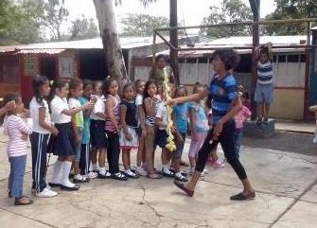

Los Pollitos School Managua
Photo: Liz Light

COMPUTER PROJECT

The NUT has been supporting a project with the National Workers’ Front, FNT, to develop computer skills for trade unionists. Details of the project can be found here The delegation visited the FNT’s training centre IHFOCATT, where the project is based. The computers have been well used and a further stage of the project is being developed.

JO COX

The delegation learned of the death of Jo Cox during the visit to FNT. The delegation was asked by the FNT to send a message of condolence and solidarity to the Labour Party and the TUC which was done. The meeting at the Education Commission opened with a minute's silence in memory of Jo Cox.

